# Business Intelligence Report (Analysis)

# A business intelligence report will be produced for Giant Bikes Company, which will comprise several dashboards that provide a thorough examination of the data through visualizations. These dashboards will showcase the key findings from the analysis of the company's data set and provide descriptive insights, evaluations, recommendations, and suggested improvements to address any identified issues.

# 5.1: Overall Performance Dashboard of Giant Bikes Company

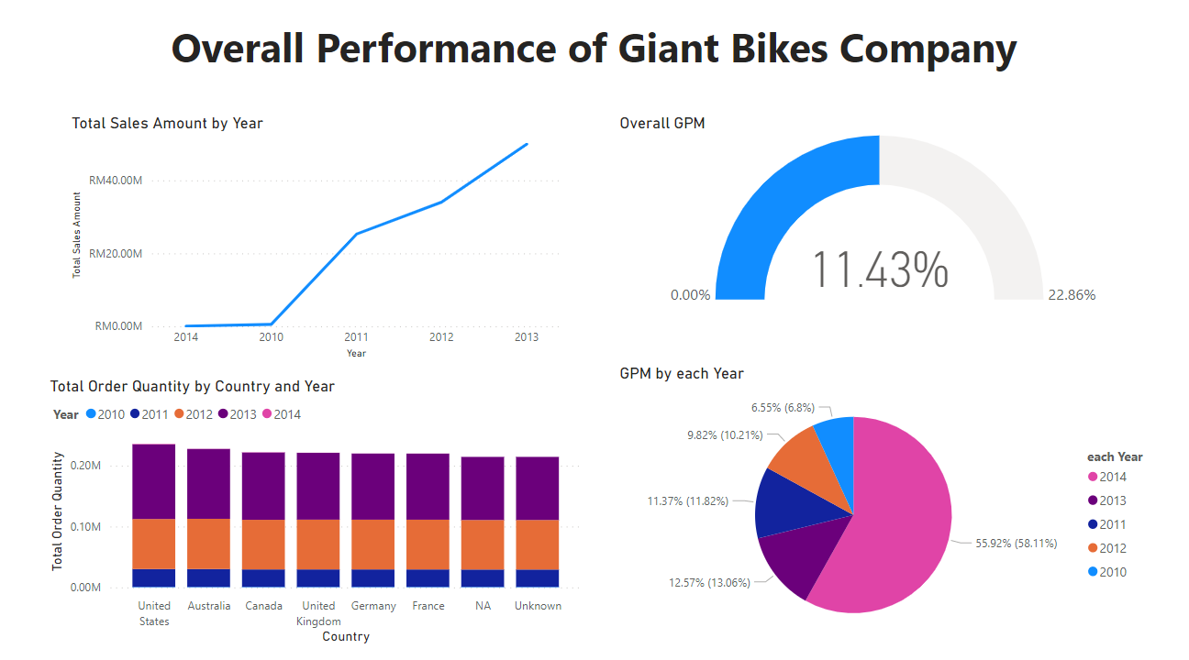

Figure 11: Overall Performance Dashboard of Giant Bikes Company

Figure 11 has shown that the dashboard of overall performance of giant bikes corporation. There were 4 analysis created in the dashboard regarding the company performance in few aspects, including total sales amount based on year, overall gross profit margin (GPM) where GPM indicates the financial status which used in business to measure the profitability within an organization (Andrew Bloomenthal, 2021), total order quantity by country and year, and the GPM by each stated year. Each analysis will be discussed separately in the later sections. The purpose of the dashboard is to enable analyst in understanding the performances as well as the situations that the company possessed through the years and eventually, come up with detailed analysis in each aspect in order to improve or transform existing business strategies.

# 5.1.1: Total Sales Amount of Giant Bikes Company by each year

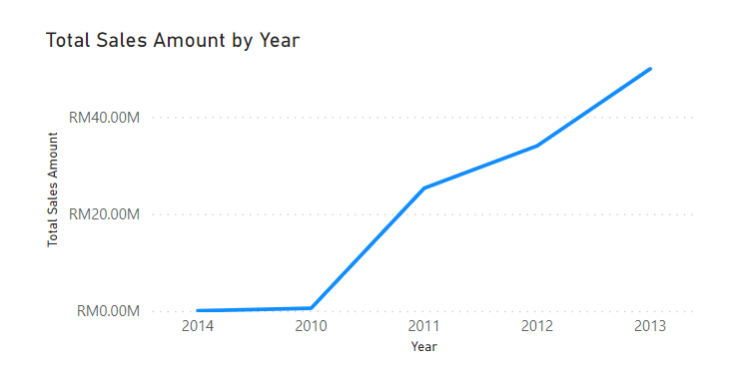

Figure 12: Total Sales Amount Visualization of Giant Bikes Company by Year

Figure 12 shows a line chart that visualized the total sales amount of giant bikes company from the year 2010 until 2014. The figure had shown that the year 2014 has the lowest sales amount with value of RM45,694.72 followed by the 2010 with amount of RM532,749.62. The year 2013 has total sales amount of RM49,926,384.50 which considered the highest among all. Year 2011 and 2012 will be the third and second with total sales amount of RM25,268,328.64 and RM34,036,116.73 respectively. Based on the visualization, analyst can assume that year 2010 is the year that the company just started off its businesses. The total sales amount had increased direct proportionally until the year 2013, then decreased approximately RM50 millions of sales amount in year 2014. In this case, analyst can gain insights on the factors of increasing in sales amount throughout the respective years, especially in the year 2013 as it has the highest amount among them. However, analyst should also take a deep discovery on the year 2014 to identify the factors of decreased in massive amount of sales.

# 5.1.2: Total Order Quantity based on country and year

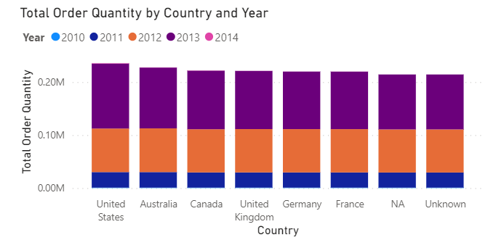

Figure 13: Visualization of Total Order Quantity by Country and Year

Figure 13 shows visualization of bar graph regarding the total order quantity of each country through the years. The figure had shown that united states ordered the most quantity of product from giant bikes company, followed by Australia, Canada, and so on. Despite the fact that united states have the highest among all, the ordered quantity difference between the countries is small, which indicates that the product order performance is still stable for the company at some point. The order quantity is the highest in year 2013 for each country, which also satisfy the fact that year 2013 has the highest amount of sales that shown in the previous figure (figure 2). The value of order quantity in the year 2010 and 2014 is too low that they did not showed in the bar graph of each country. The visualization enable analyst to focus on analysing the order quantity which will further break down into aspects including internet and reseller sales. By doing so, analyst can understand the reasons behind the increased and decreased of order quantity which can provide essential insights on company’s sales performance and market demand of its product.

# 5.1.3: Total Order Quantity based on country and year

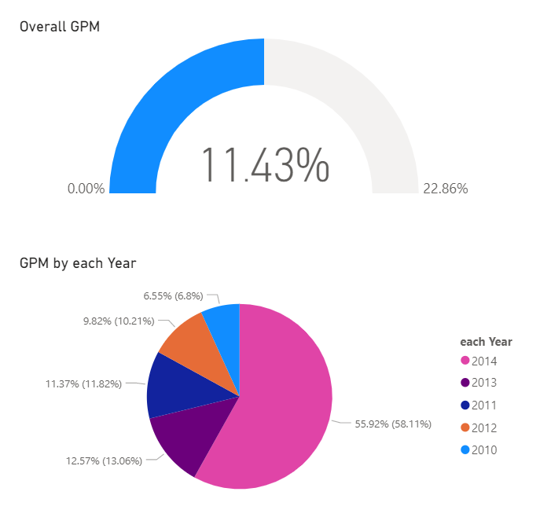

Figure 14: GPM visualization of Giant Bikes Company

In figure 14, it shows 2 visualizations including the overall GPM and GPM based on each year of the company. Overall GPM of giant bikes company is 11.43% which considered slightly above average where 10 percent of GPM is average, 20 percent as a high and strong GPM, and 5 percent counted as low GPM (Indeed Editorial Team, 2022). Hence, the value of the overall GPM can be viewed as a good sign for a company, as it implies that the business is making a sizable profit from its sales after deducting the cost of goods sold (COGS). Although there the overall GPM was above average, the GPM of internet and reseller sales will be generated to analyse their performances with separate dashboards that will be presented later. Furthermore, a pie chart has been generated to present the GPM value in each year. In the shown pie chart, GPM of year 2014 possesses the highest value which was 58.11 percent. However, figure 12 has shown year 2014 had the lowest amount of sales. According to a research, if a corporation has significant indirect costs for things like marketing or capital investment allocations, it may have a high gross profit margin but a low operational profit margin (Brian Beers, 2021). Moreover, a change in product mix, cost-cutting initiatives, modifications to market conditions, or a change in pricing strategy may all be indicated by a high gross profit margin (GPM) in conjunction with a low sales volume (Tim Parker, 2022; Justin Johnson). To identify the root problem, more investigation is required by the analyst. Therefore, since both sales volume and GPM play a significant role in a company's financial performance, having a high GPM is not always a guarantee of success. It is reasonable that the year 2010 has the lowest GPM as the business just started, then the company had increased in GPM to slightly above average in year after which is 2011, but had a slightly below average again in the year 2012 which will need to investigate the factors causing it. The year 2013 will be highly investigated due to it has the highest sales amount and an above average GPM in order to provide insights from the existing strategies in each aspect and carry out possible improvement.

# 5.2: Giant Bikes Company Performance on Internet Sales

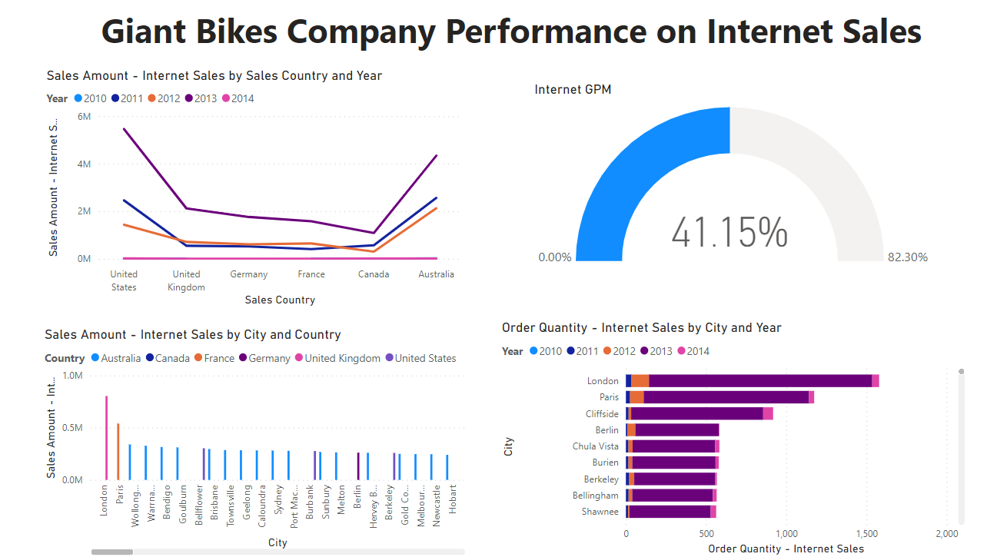

Figure 15: Dashboard of Giant Bikes Company Performance on Internet Sales

Figure 15 shows that the dashboard of Giant Bikes Company performance on internet sales. The purpose of the dashboard is to enable analyst to discover and investigate the performance of internet sales in several aspects as shown in the figure. Each aspect will be analysed separately using different type of visualizations.

# 5.2.1: Internet sales amount based on country and year

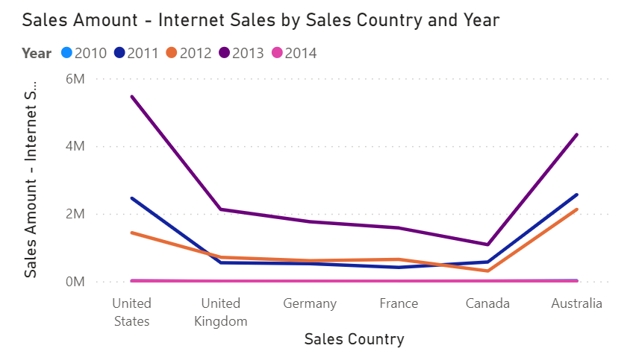

Figure 16: Visualization of Internet sales amount based on country and year

Figure 16 shows that the visualization of line chart regarding total internet sales amount of each country and categorized by year. Based on the line chart, united states have the highest internet sales amount among all, followed by Australia, United Kingdom, Germany, France and Canada. However, the sales amount between the year 2011 and 2012 is unstable as the internet sales amount had drop in united states, Canada and Australia from year 2011 to 2012; United Kingdom, Germany, France rise in internet sales from year 2011 to 2012. The findings satisfy on the reason which GPM of 2012 is lower than 2011 shown in figure 14.

According to the findings, the fact that United States has the highest Internet Sales Amount among all countries, which indicates it is a key market for the company to be focus on for further growth and expansion of the business. This indicates that the company should focus on specific countries where they are experiencing growth in Internet Sales Amount and develop more strategies to enhance on these opportunities.

The instability of internet sales between 2011 and 2012 able to provide insight concerning the market is volatile and the company will have to be prepared to adapt to changes possibly in either consumer behaviour and market trends. Furthermore, it is possible that there are country specific trends and factors affecting internet sales amount given the variations in sales growth among countries. To identify potential changes that could affect internet sales, businesses should regularly study market trends which it is highly related on the products and costumer behaviour in each country.

Internet sales are also highly dependent on the e-commerce platform. There is a possibility where the e-commerce platform is not user friendly, and there are insufficient online advertisements in countries that have low internet sales amount through the respective years. Giant Bikes Company should invest more on online infrastructure to improve e-commerce capabilities such as self-service account management, order management, buying experience and product content experience (liferay) to enhance customer experiences. By doing so, company could improve website design, streamlining checkout process, and increasing of mobile capability.

# 5.2.2: Internet sales GPM of Giant Bikes Company

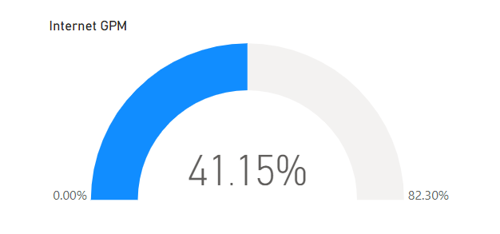

Figure 17: Internet sales GPM Visualization of Giant Bikes Company

Figure 17 shows that the Internet sales GPM of the company which possessed of 41.15 percent. The GPM indicates that the business is making a balance from its online sales, indicating that its online business strategy is working well and effectively managing its cost due to the high profit margin compared to the amount of sales. With the relatively high GPM, company could try to explore new markets to boost their Internet Sales Amount and possibly raise their profit margins, for instance, they might add more countries to their internet connection. Most importantly, the company should maintain efforts in controlling costs, which include negotiating acceptable terms with spare part suppliers and optimizing distribution in marketing expenses. In addition, the company should also focus on continuing selling products with high profit margins to maximize profits from their Internet sales.

# 5.2.3: Internet Sales Amount by City and Country

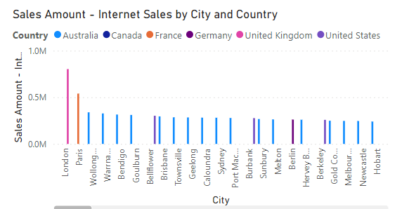

Figure 18: Visualization of internet sales amount by city and country

The bar graph shown in figure 18 visualize the internet sales amount in each city and had been categorized by country. The city London has the highest internet sales amount followed by Paris and so on as shown in the figure. Rather than discover every of the cities as there were many of them, analyst can analyse the factors that made a city had high amount of internet sales which were London and Paris. Based on the findings, cities with high internet sales amounts, such as London and Paris, indicate a large market potential for e-commerce and suggest that these cities may be valuable targets for investment and expansion. Other than that, the company can more effectively target its marketing efforts and enhance its products to these customers by understanding the elements, such as customer preferences and purchasing behaviours as mentioned before, that can contribute to strong internet sales in certain cities, especially for those cities with relatively low internet sales. Despite the fact that company should focus on cities with high internet sales, the company should modify its marketing efforts to better target the specific preferences and purchasing habits of customers even in cities with low internet sales in order to well-balance the internet sales with high performance cities. By doing so, in order to boost client engagement and increase sales in each city especially with the one that have low internet sales, the company will have to improve the user experience on its website by including features such as personalised suggestions and enhancing the website navigation (Matteo Duo, 2023). Moreover, by considering the information of customer preferences and purchasing behaviours, company can expand its product offering to better serve customers in those cities.

5.2.4: Internet Order Quantity based on each City and Year

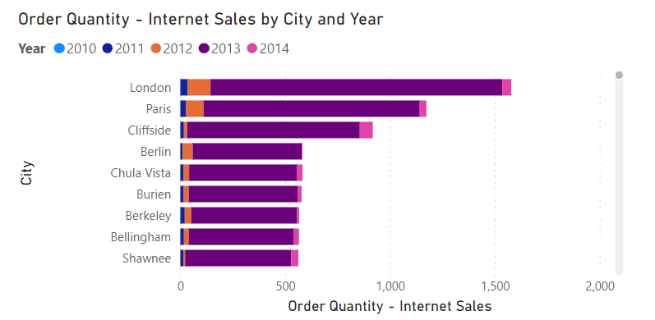

Figure 19: Visualization of Internet Order Quantity based on each City and Year

Figure 19 displays a stacked bar graph that visualizes the order quantity of internet sales for each city and categorizes it by year. In conjunction with the previous figure (Figure 18), this visualization differs from the order quantity for each year. As Figure 12 indicates, the highest sales amount was observed in the year 2013, so it is reasonable to expect a relatively large amount of order quantity in that year compared to other years. Several factors may have contributed to this situation, including marketing trends, customer behaviours, product performance, and competition as discussed earlier. The company should take these factors into consideration when analysing the results. In-depth analysis can be conducted using dashboards such as customer performance and product performance dashboards to gain further insights and improve future strategies, if necessary.

# 5.3: Reseller Sales Performance of Giant Bikes Company

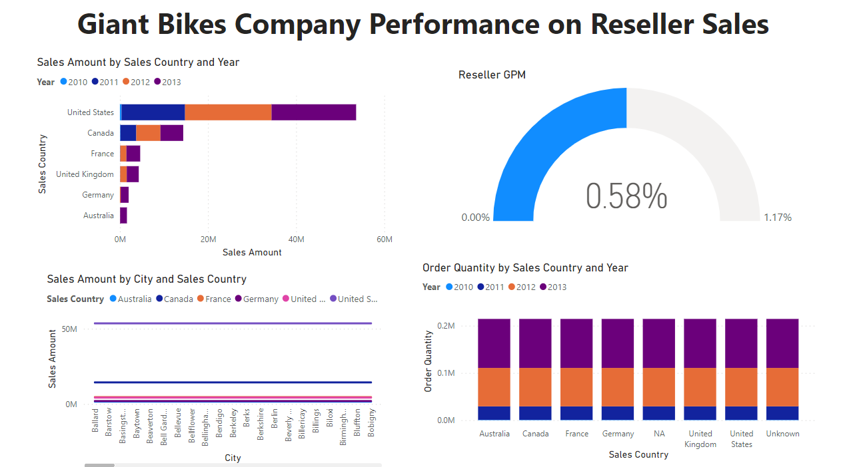

Figure 20: Reseller Sales Performance Dashboard of Giant Bikes Company

Figure 20 shows a dashboard about reseller sales performance of giant bikes company. The dashboard enable analyst to provide insights of the performance on reseller sites and conduct necessary improvement. Several aspects will be analysed separately with different kind of visualization as shown in the figure.

# 5.3.1: Reseller Sales Amount by country and year

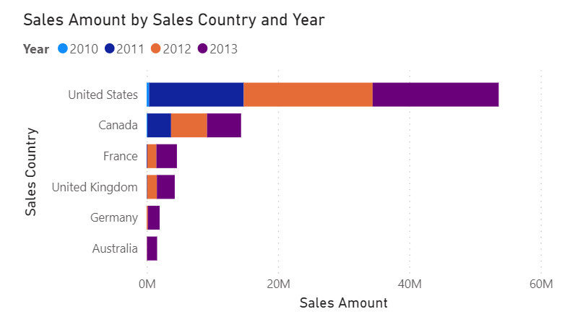

Figure 21: Visualization of Reseller Sales Amount based on country and year

Figure 21 shows that the total sales amount of resellers based on each country and year. Resellers in United states have the highest sales among other country. In the previous dashboard of internet sales performance, the amount in the year 2013 was the highest in each aspect, and year 2012 had weak performance compare to the year 2011 and 2013. However, in the reseller sales performance, the amount in the year 2012 is almost same as the year 2013 in most of the countries including United States, Canada, France and United Kingdom. With the highest sales amount in either internet (figure 16) and reseller sales, united states market is a main priority for the company. The strategies that utilized in united states should be well maintained and yet, it is important to also consider the performance of resellers in other countries. Good Strategies should be in place in supporting and growing sales in these markets as well to objectively balance the business environment of the company. Despite the poor performance from internet sales, 2012 saw relatively strong sales from resellers, indicating that there may have been some factors that led to their success in reselling. Future strategies should consider these elements and take them into account. To be mentioned that the visualization has no data of the year 2014, this can assume that the dataset has lack of reseller information in the particular year, or the company decided to not expand in reselling business and focus more on internet sales. More insights might be evaluated in the later visualizations which will be presented later.

# 5.3.2: Reseller GPM of Giant Bikes Company

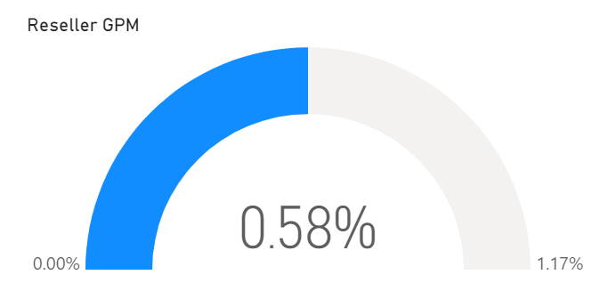

Figure 22: Visualization of Reseller GPM of Giant Bikes Company

Figure 22 displays a gauge that visualize the reseller GPM of Giant Bikes Company. The GPM of reseller sales is 0.58 percent. The percentage value is considered under average which indicates that the company might not effectively controlling the costs, or the company is selling at a low profit margin. There is a possibility where there is intense competition happening in reselling business throughout the years. Not only that, this might be the reason where the year 2014 did not display in the visualization of figure 21, the company was undergoing weak performance on reselling which leads the company to not involve in reselling business. In improving the performance of reselling, the company could use a variety of techniques including better cost control, raising product prices, or enhancing product quality to make it more desirable to clients, to increase reseller GPM (American Express, 2022). In order to spread the word about its products, the company can also consider in enhancing its marketing awareness. Alternatively, this could investigate into new distribution options to reach a wider range of customers. Additionally, in order to identify areas where it may improve, analyst will carry out more thorough analysis of other aspects which might affect the reseller sales performance.

# 5.3.3: Reseller sales amount based on city and country

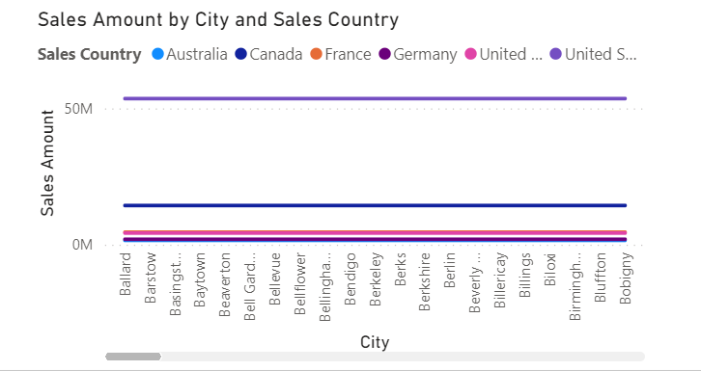

Figure 23: Visualization of Reseller Sales Amount by city and country

Figure 23 displays a line graph that visualize the reseller sales amount based on the cities and countries. According to the line graph, the reseller sales amount is extremely stable, yet only the sales amount different of each country. This may indicate that the company's reseller sales channels are effective and that resellers consistently produce strong sales outcomes. It would be beneficial for the company to investigate aspects that contribute to the difference in sales performance between countries in order to get additional knowledge and suggestions, including analysing customer demographics, competition, marketing and product performance, among others. Moreover, the performance of sales amount had be shown that is acceptable for a running business, which indicates the reason of extremely low of reseller GPM might be the cost performance of the company in either the cost of product, operations expenses and many more. Further analysis of cost performance will be discussed later in the cost performance dashboard. Regarding customer demographics, it is also reasonable where United Sates had the highest sales amount due to the country ranked the third in population among the world (World Population Review, 2023). Based on the insights discovered, the company can then implement improvements to its reseller sales strategies, increase assistance and optimize its marketing and product strategies to boost sales for underperforming countries.

# 5.3.4: Reseller Order Quantity based on Country and Year

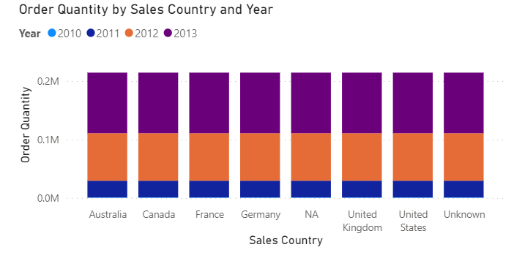

Figure 24: Visualization of Reseller Order Quantity by Country and Year

Figure 24 shows a stacked column chart visualizing the order quantity of resellers based on each country and stacked with each year. The order quantity in the year 2012 and 2013 is steady for each country which this finding satisfied the fact that the sales amount between the same years is also stable as shown in figure 23. The order quantity between each country is approximately the same which indicates that the strategies utilized reseller sales are on the right tracks. The strategies applied here will be highly relatable to the analysis discussed shown in figure 23. This particular finding can highly support that the factor that affect the low value of reseller GPM is based on cost management of the company, which more in-depth analysis will be carry out in the cost performance dashboard.

5.4: Cost Performance of Giant Bikes Company

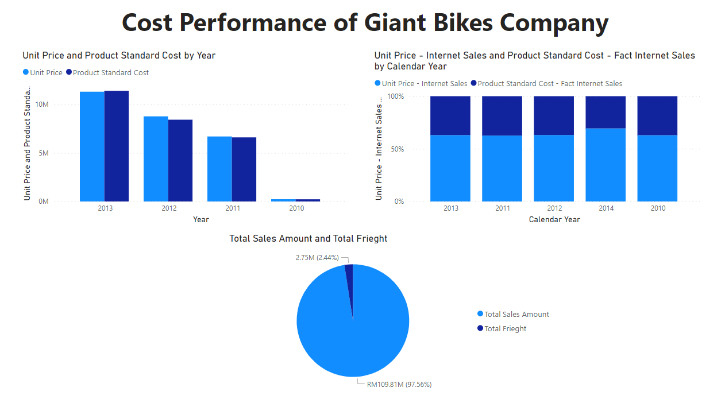

Figure 25: Cost Performance Dashboard of Giant Bikes Company

Figure 25 displays the dashboard that analyse the cost performance of giant bikes company. The dashboard included analysis of several aspects regarding cost performance of the company mainly the product and freight cost. The dashboard enable analyst to gain insights on whether the company needed to improve the existing cost management strategies in minimizing the cost and maximizing the profits.

# 5.4.1: Difference between product unit price and standard cost by year

# (Reseller Sales)

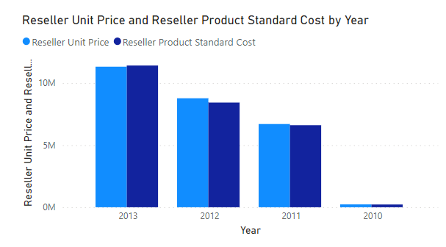

Figure 26: Visualization of Difference between Product Unit Price and standard cost based on year

Figure 26 shows a clustered column chart that visualized the difference of reseller sales in product unit price and standard cost based on year. According to the visualization, there is small difference between product unit price and standard cost in each year which indicates that the company is pricing their products close to the cost of production. This could be a good sign as it suggests that the company is not overcharging their customers, but at the same time, it could also mean that the company is not earning much profit from their sales which made the overall reseller GPM gone really low. However, in the year 2013, the amount of product standard cost is slightly higher than the amount of unit price, indicating that the company profits were not able to cover the cost of products which also other factor that cause in low GPM value. In improving the current strategies on cost management, the company can examine the pricing strategy to see whether there is space to raise prices and maximize profits (Indeed Editorial Team, 2021). Otherwise, the company will need to evaluate the production process to determine whether any cost-cutting measures may be put in place. Furthermore, monitoring market trends and competition enable in ensuring the company on pricing their products competitively. The provided strategies and recommendations will able to increase the reseller GPM percentage value and eventually, revitalize the reselling market to increase the company's revenue and profitability.

5.4.2: Difference between product unit price and standard cost by year

(Internet Sales)

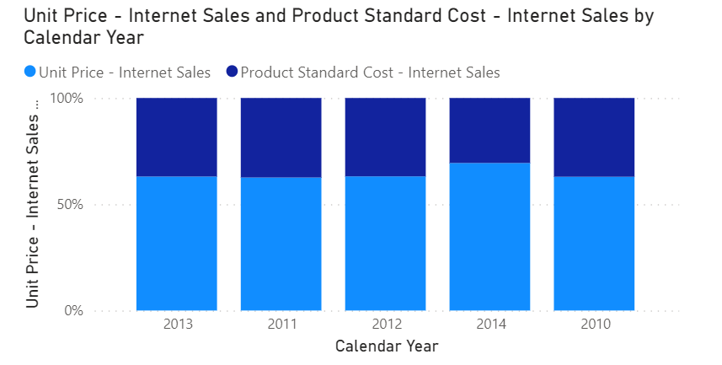

Figure 27: Visualization of Difference between product unit price and standard cost by year (Internet Sales)

Figure 27 displays a percentage stacked column chart regarding the difference of internet sales in between product unit price and standard cost based on each year. Throughout the years, the amount unit price is relatively high compared to the product standard cost which could be the factor that made the internet sales GPM to possess a high percentage value as shown in figure 17. This can also be an indication that the company is earning profits from the internet sales which can be consider as one of the future pathways for company. However, it is advised that the corporation keep an eye on the difference between the unit price and the standard cost on a frequent basis to make sure it is in line with its pricing strategy and objectives for profitability. The company could also consider adjusting possible pricing strategy in optimizing profitability while still able to be competitive in the market.

# 5.4.3: Analysis of Total Amount Sales and Freight

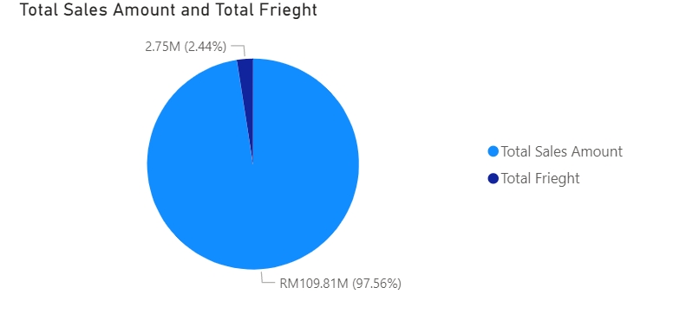

Figure 28: Visualization of total sales amount and total freight

Figure 28 shows a pie chart that visualize the relation between the total amount of sales and freight. The purpose of this visualization is to let company in understanding whether the cost of freight had affected the profits of the company. Apparently, the pie chart had shown that the total amount of sales was approximately 40 times larger than the total amount of freighting. This demonstrates that the company's overall profits are not significantly impacted by the cost of freighting. According to this information, the company might not need to prioritise lowering freight costs and instead concentrate on other areas that might have a bigger influence on the total profitability of the business. Despite the fact that freight cost is extremely low, the company should continue to oversee on freight costs to make sure they stay under control and do not rise exponentially in the future. The business should also take into consideration that by any chance, to lower freight costs without negatively impact the standard of delivery services offered to clients.

# 5.5: Discount Performance of Giant Bikes Company

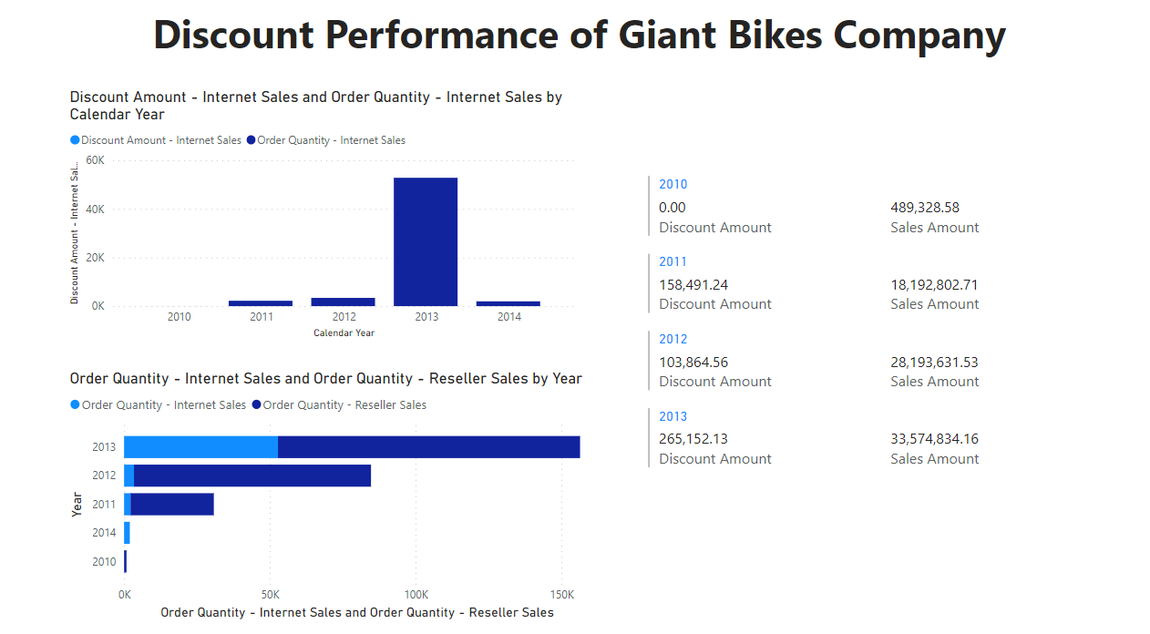

Figure 29: Discount Performance Dashboard of Giant Bikes Company

Figure 29 shows the dashboard with regard to discount performance of Giant Bikes company. The objective of the dashboard is to enable the company to have better insights on the impact of discounts brought into the business. Discounts is an important element when coming to sales as it can increased the sales volumes, attract new customers, improve in cash flow, build customer loyalty and able to compete with other companies (Nichita Herput, 2020), which considered a crucial part within a business. Therefore, a dashboard that analyse discount performance of the company is highly valuable in this case. There are 4 different visualization that enable analyst to gain insights from and to criticise or improve in the existing strategies.

# 5.5.1: Analysis of Discount Amount and Order Quantity of Internet

# sales based on Year

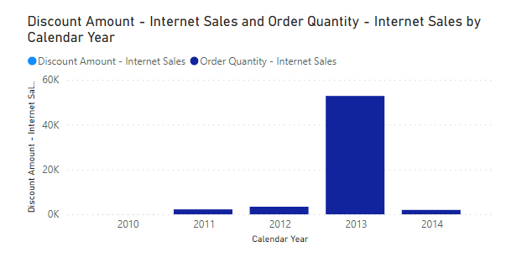

Figure 30: Visualization of discount amount and order quantity of internet sales based on year

Figure 30 shows a stacked column chart about the difference in the discount amount and order quantity of internet sales which based on year. The visualization interprets that there were no discounts throughout the years, yet the order quantity in year 2013 still has relatively high amount compared to other year. According to the data, there is no visible effect of discounts on the order quantity of online sales. This shows that for this business, discounting may not be a key component in sales growth. However, it is insufficient by relying only this analysis to conclude that discounts will not impact on internet sales. An assumption can be made is that the company might still did not implement discounts element into the internet sales. In spite of that, a deeper analysis on the crucialness of discount factors will be discovered regards the reseller sales with other dashboards which will be analysed later.

# 5.5.2: Relation between Discount Amount and Sales Amount of

# Reseller Sales

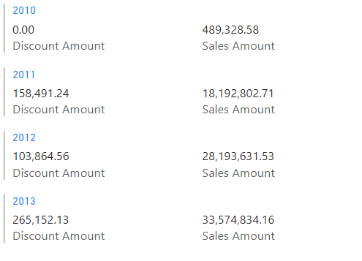

Figure 31: Visualization regarding Relation between Discount Amount and Sales Amount of Reseller Sales

Figure 31 shows that a multi-row card that visualize the amount of discount and sales in each year. The visualization clear tells that the company has provided discount to the product for reseller sales. The reseller sales amount had increased throughout the years whenever the discount amount is higher. According to the analysis, offering discounts for reseller purchases is a good approach to boost overall sales. By offering discounts more frequently or at a higher rate to raise the reseller sales volume, the company's sales strategy can be improved with the help of this insight. Additionally, regular monitoring of the relationship between discount amount and sales amount can assist the business in making wise decisions regarding sales promotions. Hence, this will be an important insight where implementing discounts in reseller sales had came out with good results, thus, company can decide in applying discounts strategies on internet sales.

# 5.5.3: Difference between Order quantity of Internet and Reseller Sales

# by Year

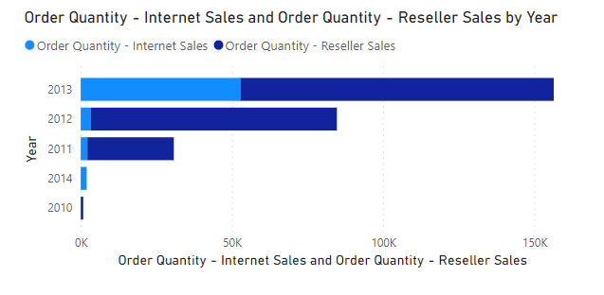

Figure 32: Visualization of Difference between order quantity of internet and reseller sales by each year

Figure 32 displays that a stacked bar chart visualizing the order quantity of internet sales and reseller sales based on the year. With implementing discounts strategy in the sales, the order quantity in reseller was relatively higher than in internet sales. According to the analysis, insight can be provided is implementing discounts has a positive influence for the company on the order quantity of reseller sales. By means that company should consider in implementing discounts as a sales strategy for internet sales to increase order. Additionally, exploration of reasons regarding the difference in order quantity between internet and reseller sales is crucial for the company and find ways to improve internet sales order quantity which required in continuously monitoring the effect of discounts on sales performance and adjust accordingly.

# 5.6: Customer Performance Dashboard of Giant Bikes Company

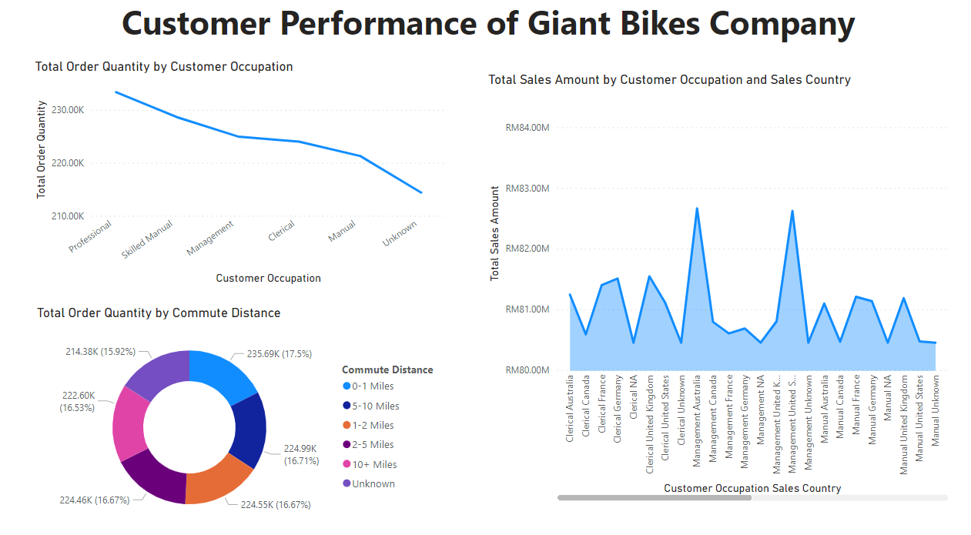

Figure 33: Visualization of Customer performance dashboard of Giant Bikes Company

Figure 33 presents a dashboard that gives a comprehensive understanding of the company's customer performance. The dashboard is crucial in evaluating customer behaviour and identifying trends that impact the company's revenue. As customers play a critical role in driving a business's success, companies strive to attract and retain customers through various strategies such as aggressive marketing, competitive pricing, and delivering exceptional products and experiences (Will Kenton, 2021). The insights from the customer performance dashboard enable the company to evaluate its current strategies and make necessary improvements to stay ahead in the competition.

# 5.6.1: Total Order Quantity in each Customer Occupation

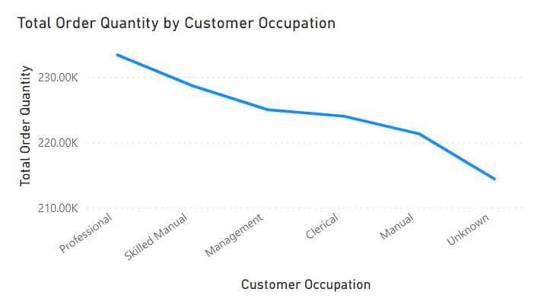

Figure 34: Visualization of Total Order Quantity in each customer occupation

Figure 34 presents a line chart that displays the total order quantity according to different occupations. The chart showcases the trend of order quantity across different occupations, with professionals having the highest order quantity, followed by skilled manual, management, clerical, manual, and unknown. Insights on customer purchasing patterns based on their profession are provided by this visualisation, which also enables the company to identify which profession drives the majority of its sales. With this information, the business may better target these high-performing occupations with its marketing and sales strategies, enhancing its overall sales performance. More in-depth analysis regarding customer occupation will be presented in other visualizations to gain more insights.

# 5.6.2: Total Sales Amount of customers’ occupation in each country

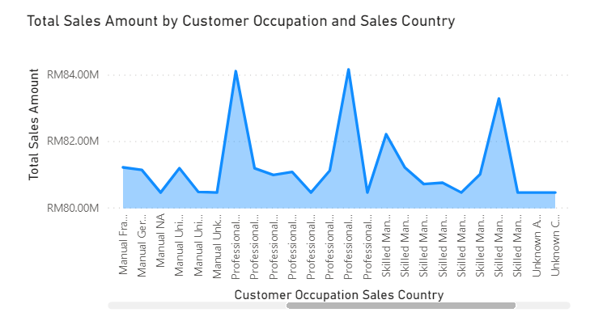

Figure 35: Visualization of Total sales amount based on customer occupation and country

Figure 35 shows an area chart that visualize customers occupation based on each country. Based on the visualization, professional that located in united states has the highest sales amount among all with a total of RM84,159,975.95, followed by professional in Australia with a total of RM84,106,246.64, Skilled Manual in United States with total RM83,281,835.67 and so on. According to the analysis, the majority of the company's customers are professionals who are primarily based in the United States, and they had contributed huge amount in sales, together with professional in Australia and skilled manual in united states. This recommends that the company may want to focus on marketing and reaching out to more professionals in the United States. It might also be beneficial to assess how well sales are performing in other occupations and countries especially those with low performance to think about upgrading marketing initiatives to boost sales there as well.

# 5.6.3: Total Order Quantity based on Customer Commute Distance

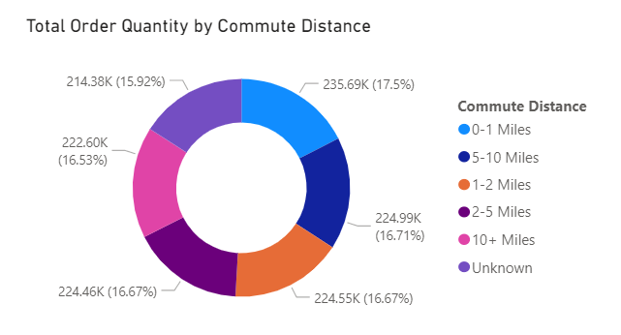

Figure 36: Total order quantity based on customer commute distance

Figure 36 represents the total order quantity of customer with relation to the commute distance. Based on the shown donut chart, the order quantity is well balanced in each type of commute distance as shown in the figure. According to the finding, it can be assumed that customer is well distributed in ordering online or on site. Based on this result, the business is successfully reaching clients regardless of where they are located or how far away they are from the business. Based on this insight, the business can consider maintaining its present strategy for customer engagement and concentrating on enhancing other aspects of its operations to boost sales and customer satisfaction.